Firmware Version: V002.002
CP Version: V01.05

1. Run the programming software, select the following option. (Program – Write Contacts)
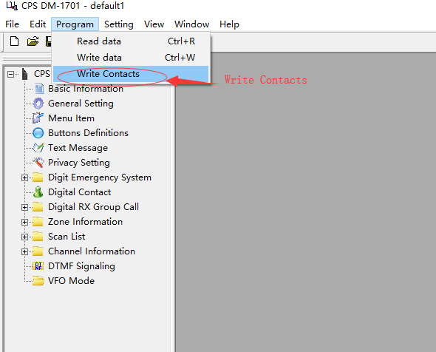

2. Click “Import” on the pop-up, select the provided csv file from your PC.
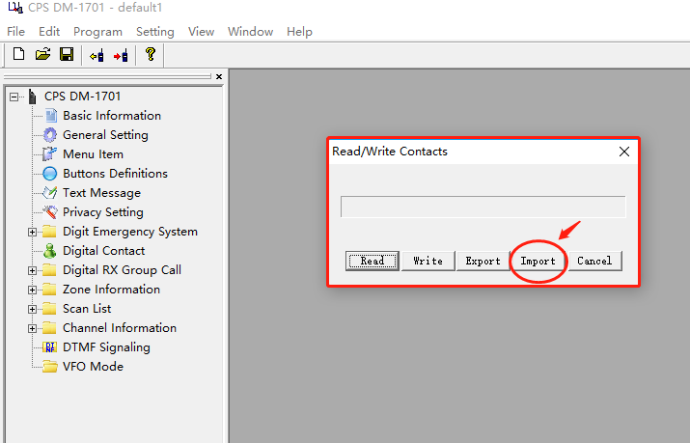
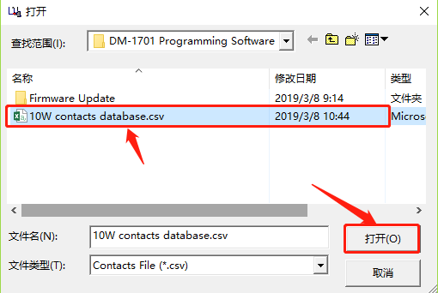
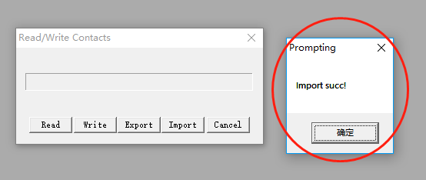

3. After import success, connect the radio to your PC with cable, turn on the radio and click “Write”. The screen of radio would display “PC Program USB Mode”, green light would keep on till finish writing (takes about 10 minutes to write 120k contacts). After success of writing, restart your radio with 120k contacts data!

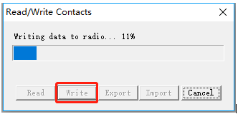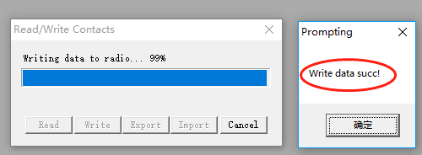

4. Confirm the import.
Check it on the radio by press MENU – Contacts – ViewContactsCSVList – ContactCSVist
